Mercy
Documenting RESTFUL APIs
Swagger Framework
Bob Adelmann
11/7/2017

Contents:

Documenting RESTFUL APIs with Swagger
Swagger is probably the most well-known framework for documenting RESTFUL APIs. It provides documentation generation and a user interface to display the documentation. It contains the following aspects:
- The OpenAPI Specification (OAS) that defines a format for describing RESTFUL APIs using JSON or YAML.
- An Editor for designing API contracts first, i.e. before any code
- Tools to generate/compute the documentation from application code
- A Web UI for displaying and executing the documented RESTFUL APIs
- Many plugins for integrating Swagger with your language/framework of choice
- Code generators for turning a Swagger spec into skeleton code (server and client)

OpenAPI Specification
A software company named SmartBear Software created the original Swagger Specification and much of the software framework. It has since donated the specification to a group called the Open API Initiative (https://www.openapis.org/). The specification’s name has been changed to the OpenAPI Specification. Members of the Open API Initiative include companies such as Google, IBM, Microsoft, Oracle, and SAP.
The specification can be viewed at https://github.com/OAI/OpenAPI-Specification.
The overview states:
“The OpenAPI Specification (OAS) defines a standard, programming language-agnostic interface description for REST APIs, which allows both humans and computers to discover and understand the capabilities of a service without requiring access to source code, additional documentation, or inspection of network traffic.”
The current version is 3.0. The repository also contains the OpenAPI Specification 2.0, which is identical to the Swagger 2.0 specification before it was renamed to “OpenAPI Specification”, as well as the Swagger 1.2 and Swagger 2.0 specifications.

Documenting an existing Spring MVC application’s RESTFUL API

The Swagger Framework provides several libraries for working with the OpenAPI Specification. They can be found at https://github.com/swagger-api. The Swagger Core library (https://github.com/swagger-api/swagger-core) implements the functionality required for generating the OpenAPI API Specification from an existing application. The current version only supports JAX-RS and plain servlets. So another library will be required for a Spring MVC application. A group of developers calling themselves Springfox have develop a suite of Java libraries that inspect the controllers in a Spring MVC application at startup and registers a documentation controller that exposes the operations the controllers allows. Their documentation can be found here http://springfox.github.io/springfox/docs/current/#introduction.

Steps for documenting an existing Spring MVC application’s RESTFUL API

- Add the SpringFox dependency to an existing Java project’s Maven pom.xml.
<dependency>
<groupId>io.springfox</groupId>
<artifactId>springfox-swagger2</artifactId>
<version>2.6.1</version>
</dependency>
Note: 2.7.0 is the latest version but I encountered a problem when using the 3.0 UI.
<dependency>
<groupId>com.fasterxml</groupId>
<artifactId>classmate</artifactId>
<version>1.3.4</version>
</dependency>
- Add a Swagger Spring Java Config Class to the project.
Add the @EnableSwagger2 annotation to the top of the configuration class and define a bean that returns a Docket object. The Docket class implements the builder pattern and allows the developer to specify configuration.
@Configuration
@EnableSwagger2
public class SwaggerConfig {
@Bean
public Docket api() {
return new Docket(DocumentationType.SWAGGER_2)
.apiInfo(apiInfo())
.select()
.apis(RequestHandlerSelectors.any())
.paths(PathSelectors.any())
.build();
}

private ApiInfo apiInfo() {
return new ApiInfoBuilder()
.title("My Mercy REST API")
.description("Authentication and Account APIs.")
.version("14.0.0")
.build();
}
}

Configuration Options:
.apiInfo() - Add an ApiInfo object to the documentation.
ApiInfo constructor:
- String title,
- String description,
- String version,
- String termsOfServiceUrl,
- Contact contact,
- String license,
- String licenseUrl
.select - returns an ApiSelectorBuilder that exposes .apis and .paths methods.
.apis(RequestHandlerSelectors.any()) - filter for Request Mapping annotations.
.paths - any URI, select URI’s based on ant selector or regex expression.

- If the Java Project is not using Spring Boot, then it will need to override the addResourceHandlers method for the configuration class that extends the WebMvcConfigurerAdapter.
@Configuration
@EnableWebMvc
@ComponentScan( basePackages = "com.mercy.mymercy.controller" )
public class RestConfig extends WebMvcConfigurerAdapter {
@Override
public void addResourceHandlers(ResourceHandlerRegistry registry) {
registry.addResourceHandler("swagger-ui.html")
.addResourceLocations("classpath:/META-INF/resources/");
registry.addResourceHandler("/webjars/**")
.addResourceLocations("classpath:/META-INF/resources/webjars/");
}
}

- Start the Rest API project and try accessing the generated api doc at http://localhost:8080/mymercywebapi/v2/api-docs. If access is denied the url needs to be added to the security configuration.
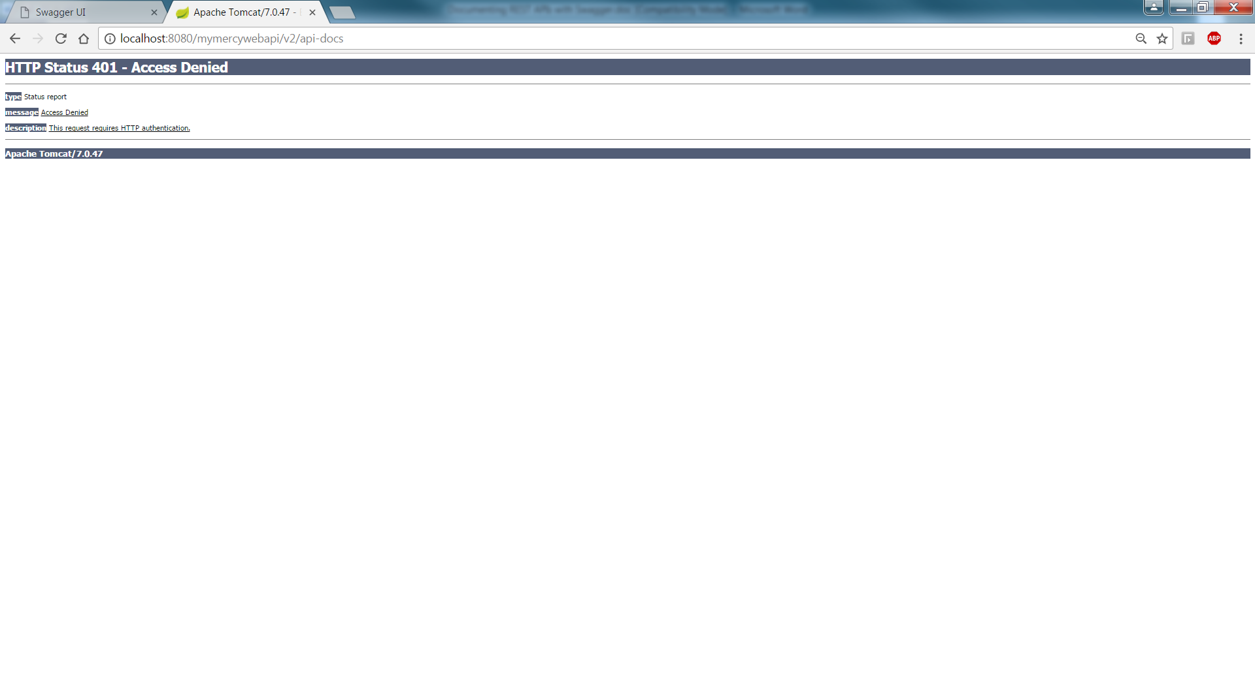
SecurityConfig.java

protected void configure(HttpSecurity http) {
try {
requireNonNull(http)
.requestMatchers()
.antMatchers("/v2/","/v2/api-docs", "/configuration/ui", "/swagger-resources/**", "/configuration/security", "/swagger-ui.html", "/webjars/**")
- Restart the Rest API project and try accessing the generated api doc. The response should be a large JSON object representing the Swagger specification of the projects REST endpoints.
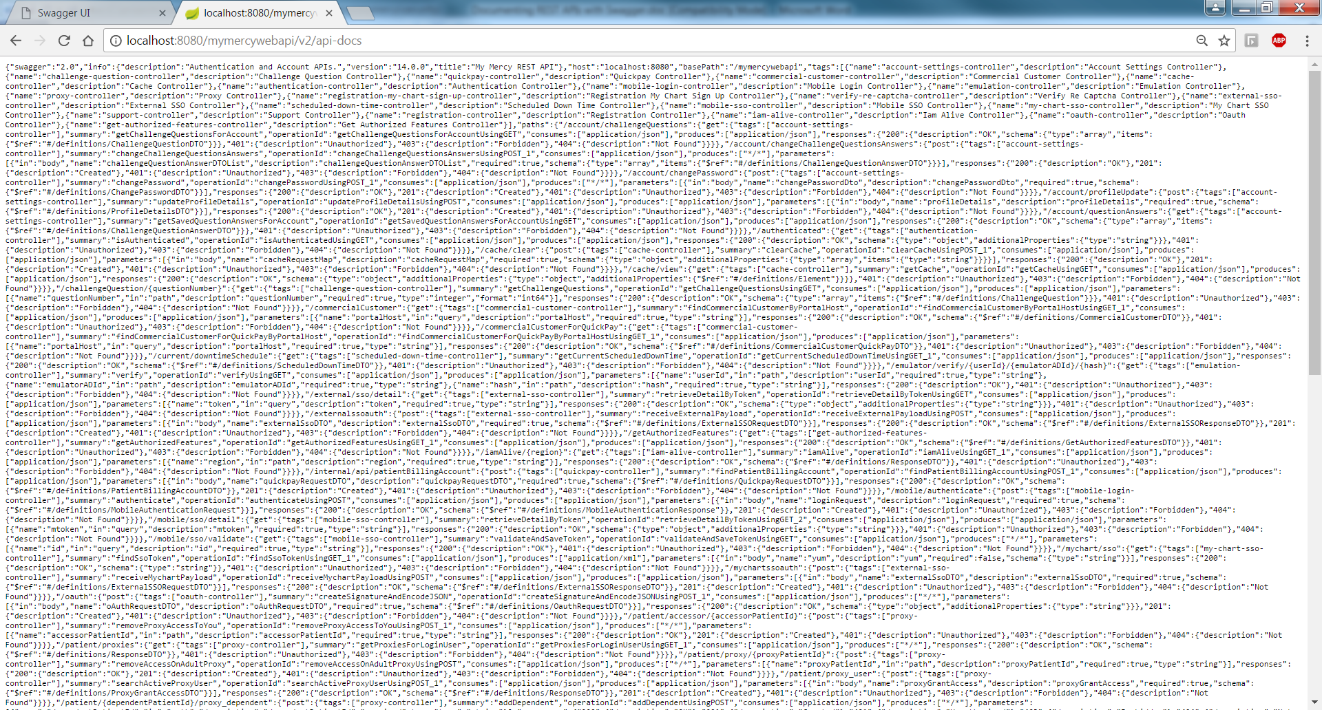
Copy and paste into the online Json editor (jsoneditonline.org) to format the result.
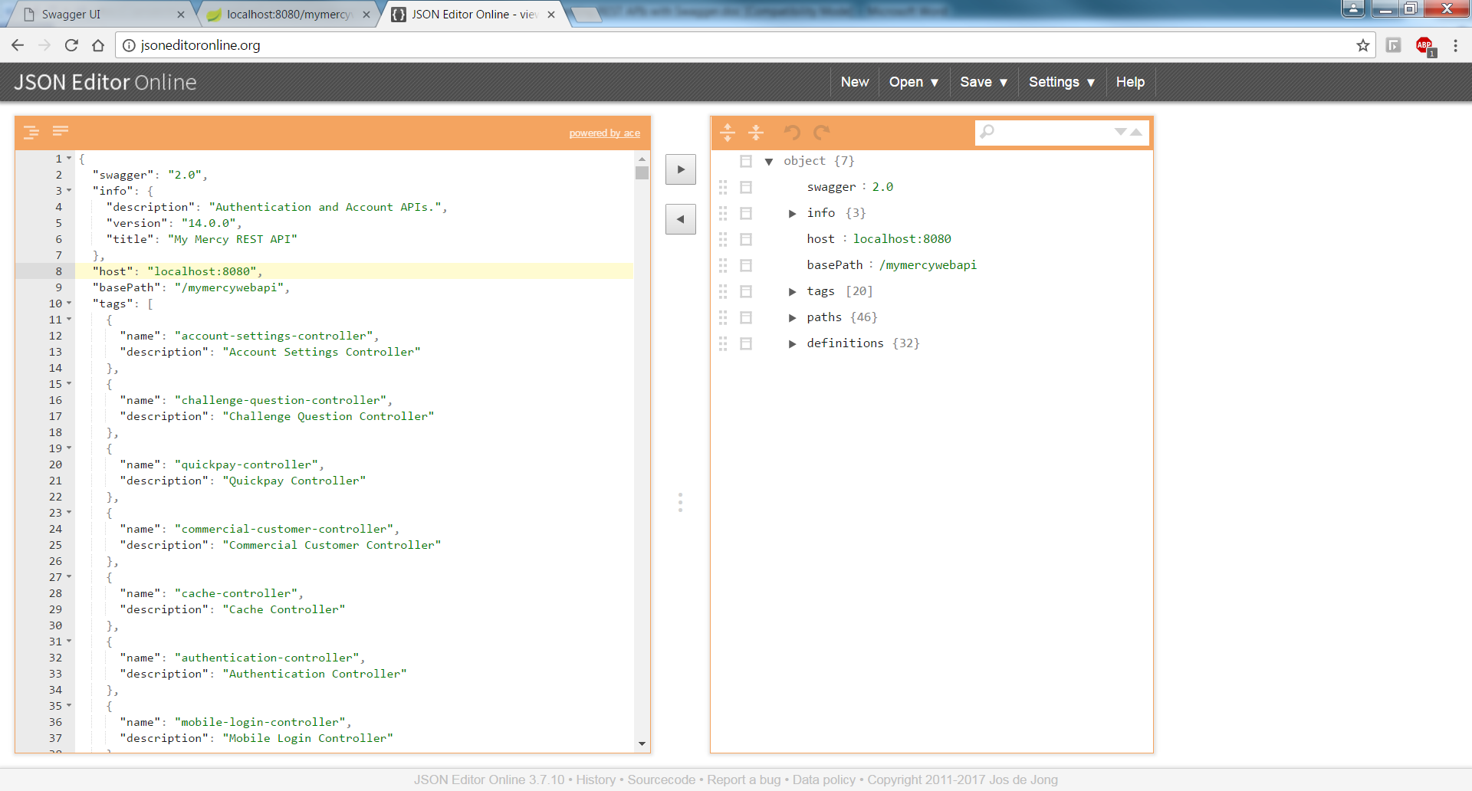

Next Steps:
- Explore options for viewing and executing the api using the Swagger UI.
- Add additional information by adding annotations to the Spring MVC Controllers.

Swagger UI
Swagger UI just expects a URL that leads to a Swagger-compliant documentation. It then uses the documentation to display all the operations.

Swagger UI also inspects the models, so finding out about the structure of the JSON documents the API expects is straightforward. Here is an example for the PUT operation:
Swagger has two different UI options for viewing and executing the API .
- Add the Springfox UI library to the project which will generate an HTML page that lists
- Use the new Swagger UI 3.x.

<dependency>
<groupId>io.springfox</groupId>
<artifactId>springfox-swagger-ui</artifactId>
<version>2.6.1</version>
</dependency>

http://localhost:8080/mymercywebapi/swagger-ui.html

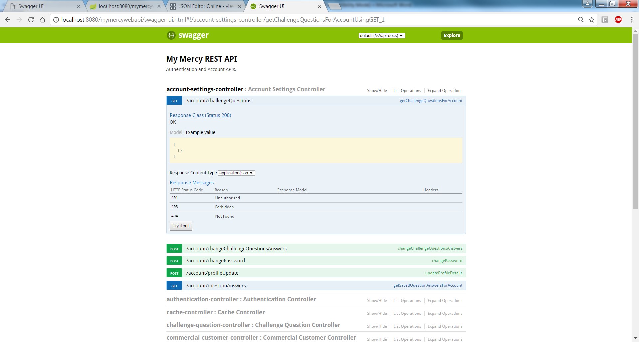
Swagger UI Version 3

- Add the path "/v2/api-docs” to the app’s CorsFilter.
@Bean
public CorsFilter corsFilter() {
UrlBasedCorsConfigurationSource source = new UrlBasedCorsConfigurationSource();
CorsConfiguration config = propertyConfig.corsConfig();
if (config.getAllowedOrigins() != null && !config.getAllowedOrigins().isEmpty()) {
source.registerCorsConfiguration("/cache/**", config);
source.registerCorsConfiguration("/mychart/sso", config);
source.registerCorsConfiguration("/externalssoauth", config);
source.registerCorsConfiguration("/mychartssoauth", config);
source.registerCorsConfiguration("/mobile/authenticate", config);
source.registerCorsConfiguration("/mobile/sso/validate", config);
source.registerCorsConfiguration("/commercialCustomerForQuickPay", config);
source.registerCorsConfiguration("/v2/api-docs", config);
}
return new CorsFilter(source);
}

- Load Swagger UI to see the listing of Spring MVC Controllers.
This is an example of using the 3.x version of the Swagger UI. This runs as a separate app. In this case it is running as a nodejs app available on port 3200. In this example the address of the api documentation is http://localhost:8080/mymercywebapi/v2/api-docs. If you put this address in a browser you will get back a large json document that describes the REST API using the OpenAPI Specification. You can copy and paste the response to the Swagger Online Editor to get a formatted look at the description of the REST API.
The Swagger UI displays the REST APIs grouped by Spring MVC Rest Controllers. To see the individual resources click on the “>” symbol on the right to expand.
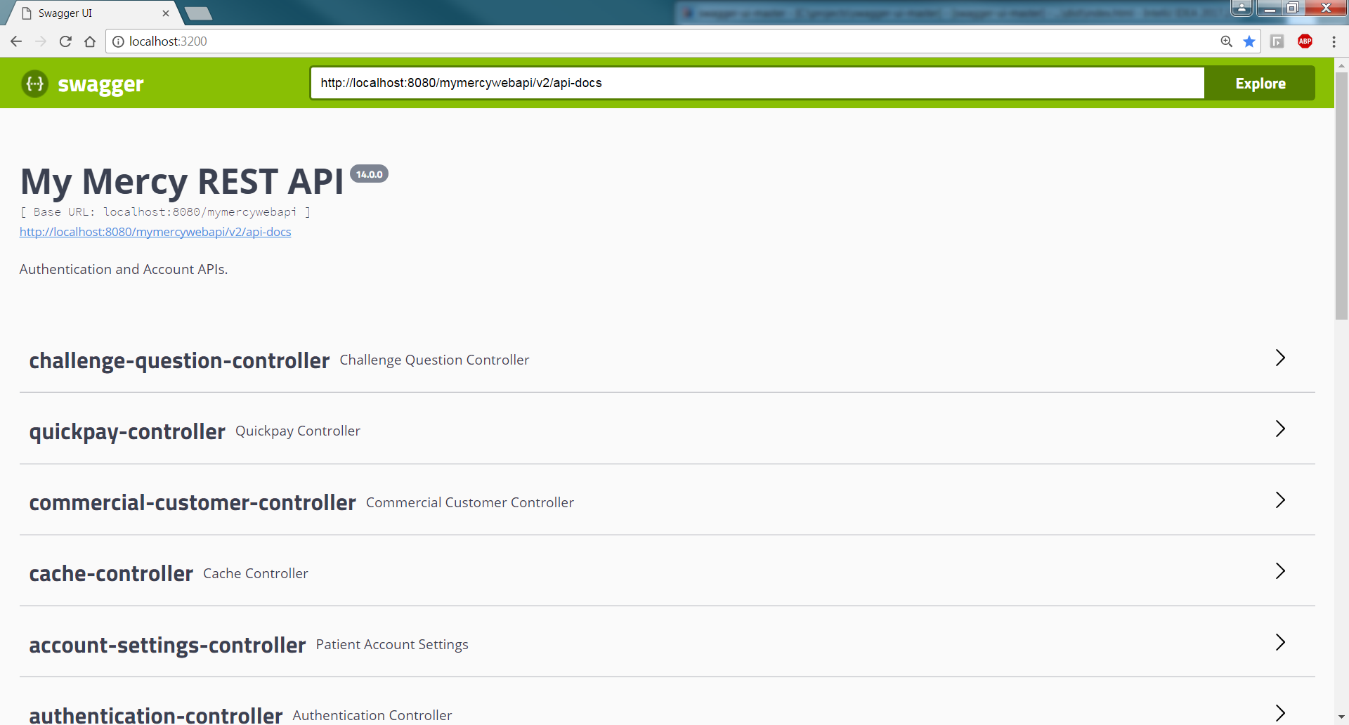
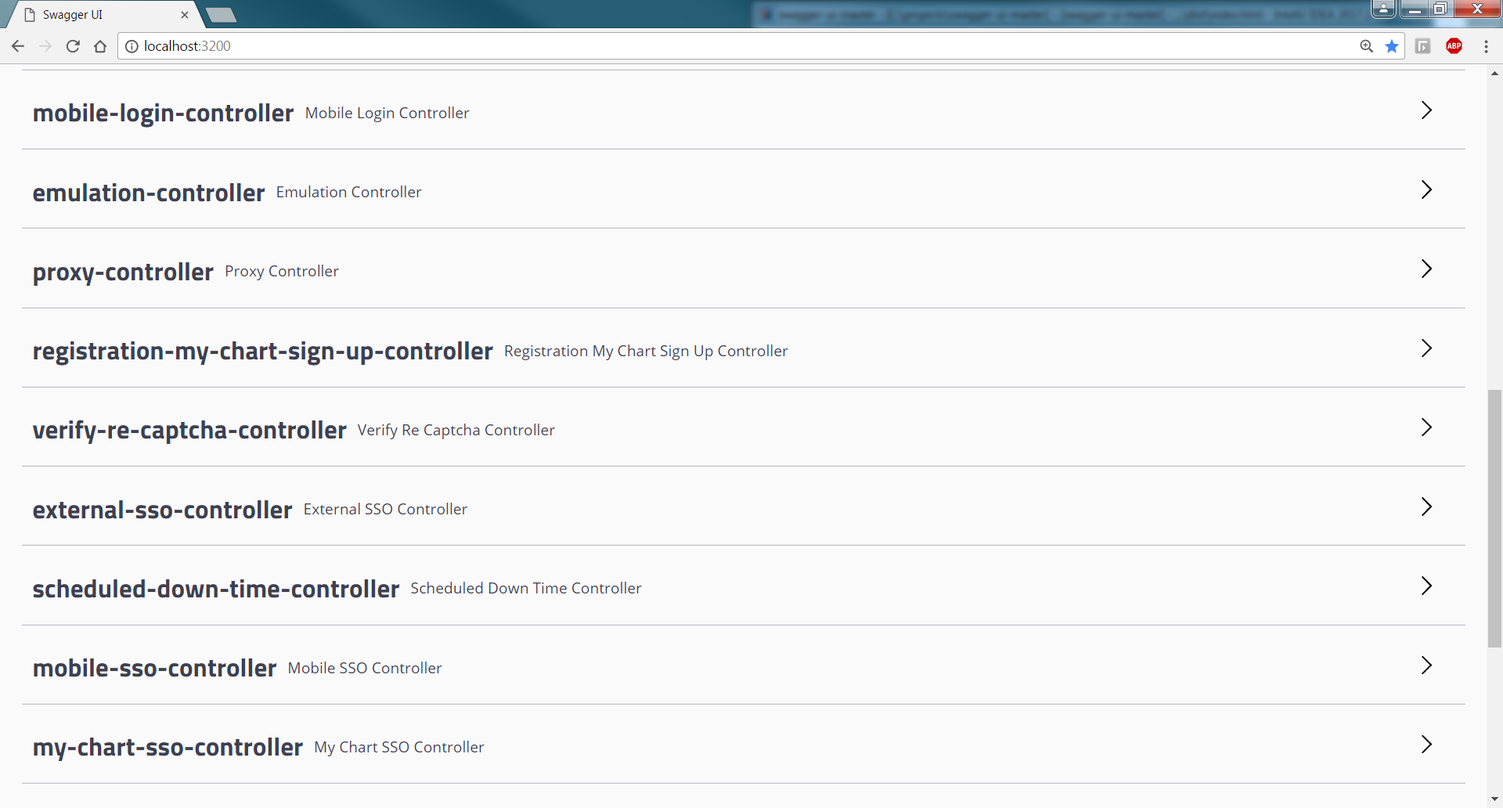
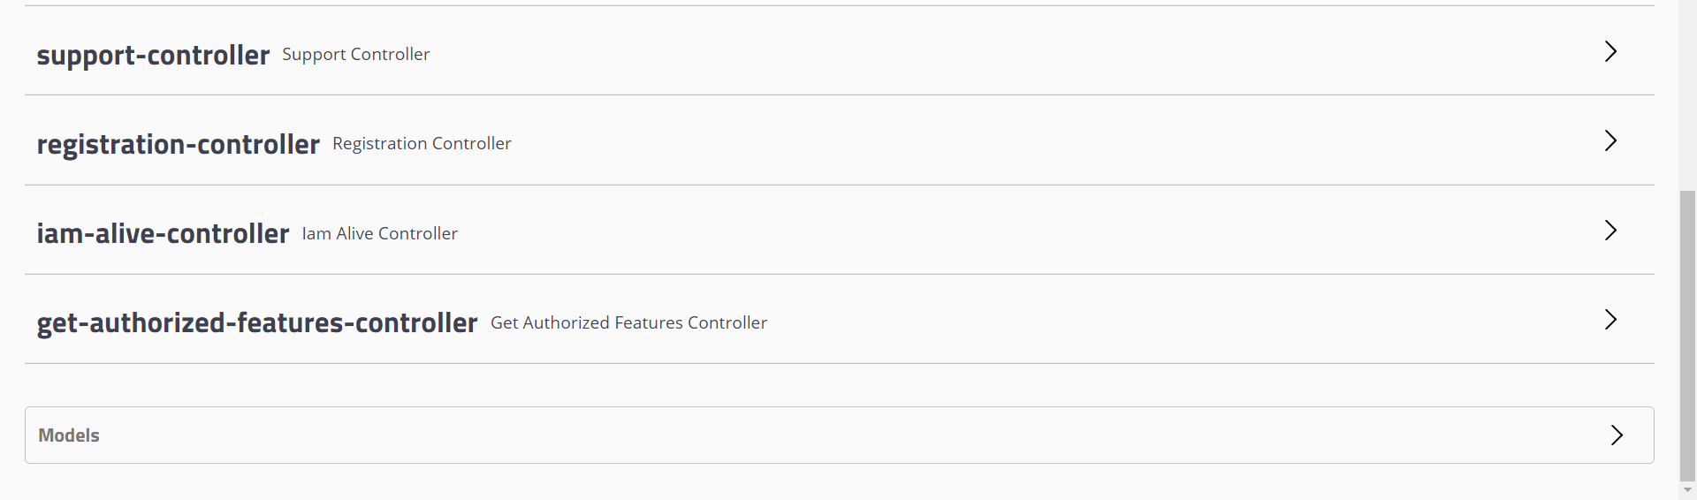

- Veiw the operations associated with a REST controller.
By exanding the challenge-question-controller entry we can see that it contains three operations. If you click on the operation you will be able to see the details of the operation as well as execute the operation.
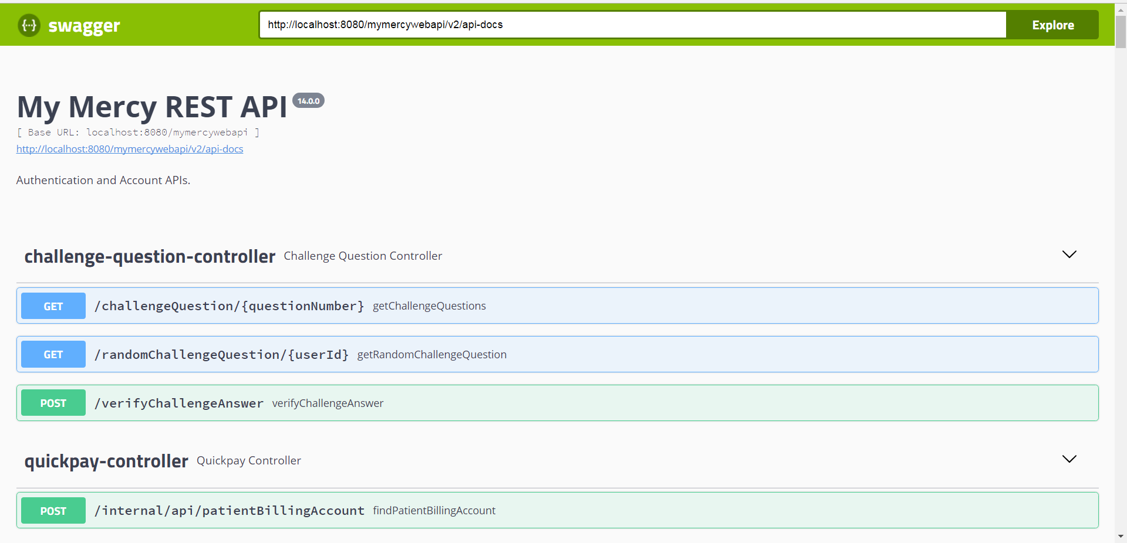

Adding Annotations to the code

Swagger annotation are not mandatory, springfox generate swagger docs for Spring MVC controllers. But, you may need them to customize your Rest API documentation.
https://springfox.github.io/springfox/docs/current/
This section introduces the annotations provided by swagger-core. They are grouped into four sections:
- Operations
- Schemas
- Info
- Security

@ApiOperation: Provides documentation for REST web service method, for example what operation this method performs.
@ApiParam: Provides documentation about parameter of REST web service method.
@ApiOperation(value = "GET the list of challenge questions setup by the user.",
response = ChallengeQuestionDTO.class,
responseContainer = "List")

https://samerabdelkafi.wordpress.com/2015/09/14/rest-api-documentation-with-swagger-and-angularjs/

